Tutorial – 10.2

**Aim:** write shell script to print the series 1,3,5,7,9,.....,N.

**Code:**echo "Enter the value of N:"

read N

echo "Series of odd numbers from 1 to $N:"

for (( i = 1; i <= N; i += 2 )); do

echo -n "$i "

done

echo ""

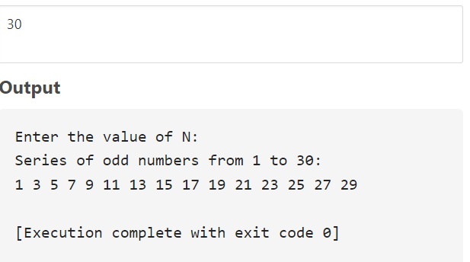**Output:**